

**Technical Report**

**On**

**Student’s Work Experience program 1 (SWEP 1)**

**Undertaken at**

**Lanre Shittu Motors (LSM) Nigeria Limited, a division of Lanre Shittu Groups**

**Mabushi, Abuja, Nigeria.**

**Prepared By**

**Orilade Emmanuel Oluwatomisin**

**17/ENG05/037**

**Submitted to**

**The Department of Mechanical and Mechatronics Engineering,**

**College of Engineering**

**Afe Babalola University, Ado-Ekiti, Ekiti State, Nigeria.**

**In Partial Fulfilment of Requirements for the Award of Bachelor of Engineering (B.Eng) Degree in Mechatronics Engineering.**

**September, 2019.**

**CERTIFICATION**

This is to certify that this work was undertaken by Orilade Emmanuel Oluwatomisin (17/ENG05/037) of the department of Mechanical and Mechatronics Engineering, at Lanre Shittu Motors (LSM) Limited, Mabushi Abuja; under the supervision of Engr. Adeboye, with the report prepared and presented to the department of Mechanical and Mechatronics Engineering, Afe Babalola University, Ado-Ekiti (ABUAD), Ekiti State, Nigeria, during the 2018/2019 Sdtudent Work Experience Programme 1 (SWEP 1).

**SUPERVISOR SIGNATURE AND DATE**

**SIGNATURE AND DATE**

**HEAD OF DEPARTMENT**

**MECHANICAL AND MECHATRONICS ENGINEERING**

**DEDICATION**

This report is dedicated to my family, friends, Department of Mechanical and Mechatronics Engineering and to my colleagues that worked with me during the period of this internship programme at Lanre Shittu Motors (LSM) Limited.

Orilade Emmanuel Oluwatomisin

300L

Mechatronics Engineering.

**ACKNOWLEDGEMENT**

I would like to appreciate the Almighty God for the wisdom and knowledge he has endowed me with.

My profound gratitude goes to Provost of the College of Engineering and the Head of Department of Mechanical and Mechatronics Engineering; Engr. Prof. A.A. Aderoba.

Very special appreciation goes to the members of the academic staff of Afe Babalola University, Ado Ekiti, Ekiti State, Nigeria. My appreciation also extends to the never relenting lecturers of Mechanical and Mechatronics Engineering for their aid in helping me execute this report successfully.

I express my special gratitude to my industrial supervisor Engr. Adebayo, for the support given to me all through my industrial training. And also, my industrial colleagues and supervisors who put me through, during the period of this training.

My thanks also go to my parents; Mr. and Mrs. Orilade for their encouragement, prayers, love, care and support they have given in all area of my life. Without them, I wouldn’t have been able to fulfil this cause.

**ABSTRACT**

The Student Work Experience Program (SWEP) is an educational scheme set up by the Federal Government to expose second and third engineering students of tertiary institutions to practical skill acquisition relevant to their course of study as well as industrial experience. It avails students of universities and polytechnics the opportunity of being familiarized and exposed to the needed experience in handling machinery and equipment. My 2018/2019 SWEP was undertaken at Lanre Shittu Motors (LSM), Nigeria Limited. Automobile servicing, repairs and maintenance operations were carried out during the process of this training. The SWEP programme enabled me to know the operations of an automobile, and how all the systems work together, in order to produce a fully functional vehicle, which in turn leads to a stress-free ride. It also exposed me to different machinery and equipment related to my field of engineering. Furthermore, it exposed me to various hazard to avoid while working on an automobile, so as to prevent injury to myself, and avoid damage of the tools in use or the vehicle being repaired. It also gave me the opportunity to experience the hard work an engineer must put into his business, in order to achieve his required aim, and I learnt about the importance of team work.

**TABLE OF CONTENTS**

**TITLE**  **PAGE**

**CERTIFICATION ……………...………………………………………………….…. i**

**DEDICATION …………………...………………………………………………….... ii**

**ACKNOWLEDGEMENT.…………………………………………………………... iii**

**ABSTRACT ………………….………………………………………………………... iv**

**LIST OF FIGURES …………………………………………………………………… vi**

**CHAPTER ONE: INTRODUCTION ……………………………………………………. 1**

* 1. Background to SWEP …………………...……………………………………………… 1
  2. Objectives to SWEP **…………………………………………………………………….** 1
  3. Log Book ………………………………………………………………………………. 2
  4. Background of the Organization ………………………………………………………... 2

1.4.1 The Role of Lanre Shittu Motors (LSM) Limited ……...……………………… 2

1.4.2 Safety Equipment and Precautions ……………………………………………... 3

1.4.3 Personal Protective Equipment …………………...……………………………. 3

**CHAPTER TWO: LITERATURE REVIEW ……………………………………….…… 4**

**2.1 The Brake System** …………………………………………………………………...…. 4

2.1.1 Components of the Brake System …………………………………………. 5 – 14

2.1.2 Common Brake System Faults and their Solutions ...…...……………… 14 - 15

**2.2.0 The Suspension System** ……………………………………………………………… 15

2.2.1 Components of the Automobile Suspension System ……………………. 16 - 19

2.2.2 Common Suspension System Faults and their Solutions ……………… 19 – 21

**2.3 The Lubrication System** ……………………………………………………………. 21

2.3.1 Components of the Lubrication System …………………………………. 22 - 23

2.3.2 Lubrication System Maintenance ……………………………………… .23 - 26

2.3.3 Common Lubrication System Faults and their Solution ………………... 26 – 28

**2.4 The Transmission System** …………………………………………………………… 29

2.4.1 Components of the Transmission System ………………………………... 30 – 31

2.4.2 Common Transmission System Faults and their Solutions …………………... 32

**CHAPTER THREE: ACTUAL WORKDONE 10**

**3.1 WORKDONE** ………………………………………………………………………...... 33

3.1.1 First Month Training …...…………………………………………………....... 33

3.1.2 Second Month Training ……………………………………………………… 34

3.1.3 Third Month Training ………………………………………………………… 35

**CHAPTER FOUR: EXPERIENCE GAINED AND CHALLENGES ENCOUNTERED ……………………………………………………………………………………………… 15**

**4.1 Experience Gained** ……………………………………………………………………… 36

**4.2 Challenges Encountered** ………………………………………………………………… 36

**CHAPTER FIVE: CONCLUSION AND RECOMMENDATION ……………………. 16**

**5.1 Conclusion** …………………………………………………………………………… 37

**5.2 Recommendation** ………………………………………………………………...…... 37

**REFERENCES ……………………………………………………………………………. 38**

**LIST OF FIGURES**

**Fig 2.1** Dual-circuit Braking System ………………………………………………………... 4

**Fig 2.2** Master and Slave Cylinders …………………………………………………………. 5

**Fig 2.3** The Brake Servo ……………………………………………………………............ 7

**Fig 2.4** Side View of a Brake Servo ………………………………………………………... 8

**Fig 2.5** Side View of a Brake Disk ……………...…………………………………………. 10

**Fig 2.6** A Comprehensive Overlay of the Disk Brake ….........………………….…………... 11

**Fig 2.7** A Comprehensive Overlay of the Drum Brake ……….……………………………. 12

**Fig 2.8** Brake Shoes …………................................................................................................ 12

**Fig 2.9** The Handbrake Mechanism ………………………………………………………… 14

**Fig 3.0** Leaf Spring and MacPherson Strut ………………………………………………… 18

**Fig 3.1** The Lubrication System ……………………………………………………………. 21

**Fig 3.2** An Engine Lubrication System ………...………………………………………….... 23

**Fig 3.3** Transmission System ……………………………………………………………...... 29

**Fig 3.4** A Torque Converter for Automatic Transmission ……………………………….… 30

**CHAPTER ONE**

**INTRODUCTION**

This report entails the activities and nature of the work done during the 2018/2019 Students Work Experience Program (SWEP) undertaken at Lanre Shittu Motors (LSM) Limited, located at Mabushi, Abuja, Nigeria.

* 1. **Background to SWEP**

SWEP similar to SIWES is a program established by the Federal Government to solve the problem of poor practical skills preparatory for employment in industries by Nigerian graduates of tertiary institutions.

The program was introduced for second- and third-year students of universities and polytechnics to enable them the opportunity to be conversant with opportunities of being familiarized to the required experiences in handling and operating industrial devices and machines which may not be readily available in tertiary institutions.

The program exposes students to industry-based skills necessary for a smooth transition from the classroom to the world of work.

* 1. **Objectives of SWEP**

The following are the objective of SWEP:

1. Provide an avenue for students in institutions in higher learning to acquire industrial skills and experience in their approved course of study.
2. Bridge the gap between theoretical and practical knowledge in uplifting of the overall base knowledge of the students to be applied in real work situations.
3. Aid students in making career choices.
4. Prepare students for the industrial work situation, which they are likely to meet after graduation.
5. Diversify the practical experience and helps students in developing attributes of teamwork and correlation with members of other profession and disciplines.
6. Exposes students to work methods and techniques in handling equipment and machinery in their institutions and industries.
   1. **Log book**

This is a daily report writing which entails the routine work done and projects handled or executed, summary of the lessons learned. The log book was inspected, examined and signed by both the industrial based supervisor and the college-based supervisor.

* 1. **Background of the Organization**

Lanre Shittu Motors (LSM) Limited, was established in 1998 as an automobile repair and maintenance company. The organization later grew into a very big industry, which also specializes in sales of automobile vehicles, as well as assembling of vehicles at their automobile assembly plant in Lagos, Nigeria.

Lanre Shittu Motors is one of Nigeria's leading automobile dealers. The number one dealer for Mack Trucks in Africa and the sole franchisee for Mack in Nigeria. The only dealer for Sany Heavy Duty Equipment and Yutong Buses in Nigeria and also an accredited dealer of KIA, NISSAN, Jinbei Buses, to name a few. Furthermore, it is Nigeria's leading supplier of genuine Spare Parts to automobile dealers in Nigeria. They also have some of the best automobile workshops in 10 states of the country.

**Lanre Shittu Motors (LSM) Limited, engages in the following operations;**

1. Repairs of automobile vehicles.
2. Maintenance of automobile vehicles.
3. Sales of automobile vehicles (Cars, Busses, Trucks, SUV’s, etc.).
4. Suppliers of genuine spare parts.
5. Automobile assembly.
   * 1. **The Role of Lanre Shittu Motors (LSM) Limited**

Lanre Shittu Motors is an organization seeking to satisfy the interest of its customers, hence offer the best automobile repair and maintenance solutions, as well as discounted rates on their automobile vehicle sales. They also have diversified the organization, through the establishment of a manufacturing plant in Lagos, Nigeria. **They are ranked as one of the best automobile industries in Nigeria.**

* + 1. **Safety Equipment and Precautions**

Safety can be described as the condition of being protected from or unlikely to cause danger risk or injury. It can be defined as the elimination or control of recognized hazard. Safety is accident prevention.

Maintenance is an activity for the upkeep of any equipment, for its safe and reliable operation through-out its useful life.

**1.4.3 Personal Protective Equipment**

The following includes the equipment worn to reduce rate or impact of accident at the site

1. Rubber gloves for hand protection
2. Safety boot for foot protection
3. Overalls for body protection

**CHAPTER TWO**

**LITERATURE REVIEW**

**2.1 THE BRAKE SYSTEM**

The brake system, is one of the most important systems in an automobile. The main function of this system, is to slow down or to completely stop a vehicle. Most modern cars have [brakes](https://www.howacarworks.com/basics/how-the-braking-system-works) on all four wheels, operated by a **hydraulic system**. The front brakes play a greater part in stopping the car than the rear ones, because braking throws the car weight forward on to the front wheels. Many cars therefore have [**disc brakes**](https://www.howacarworks.com/basics/how-the-braking-system-works) , which are generally more efficient, at the front and [**drum brakes**](https://www.howacarworks.com/basics/how-the-braking-system-works) at the rear. All-disc braking systems are used on some expensive or high-performance cars, and all-drum systems on some older or smaller cars.

[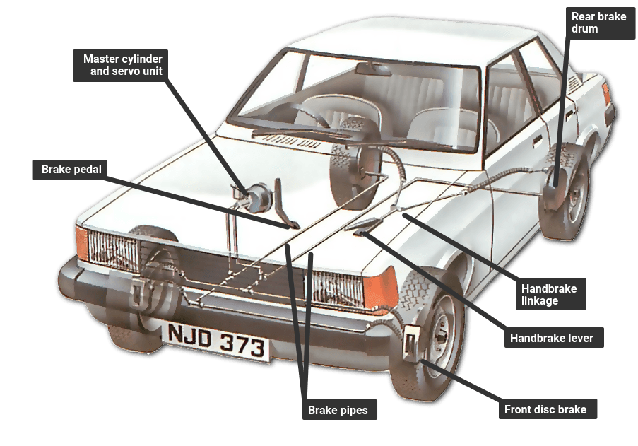](https://www.howacarworks.com/illustrations/dual-circuit-braking-system)

**Fig 2.1: Dual-circuit braking system**

**A typical dual-circuit braking system in which each circuit acts on both front wheels and one rear wheel. Pressing the brake pedal forces fluid out of the master cylinder along the brake pipes to the slave cylinders at the wheels; the master cylinder has a reservoir that keeps it full.**

**2.1.1 Components of the Brake System**

1. **Brake hydraulics:**

A hydraulic brake circuit has fluid-filled master and slave cylinders connected by pipes.

[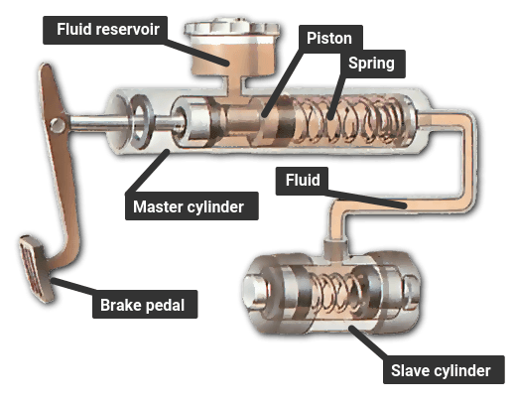](https://www.howacarworks.com/illustrations/master-and-slave-cylinders)

**Fig 2.2: Master and slave cylinders**

**The master cylinder transmits hydraulic pressure to the slave cylinder when the pedal is pressed.**

When you push the brake pedal it depresses a piston in the master cylinder , forcing fluid along the pipe.

The fluid travels to slave cylinders at each wheel and fills them, forcing pistons out to apply the brakes.

Fluid pressure distributes itself evenly around the system.

The combined surface 'pushing' area of all the slave pistons is much greater than that of the piston in the master cylinder.

Consequently, the master piston has to travel several inches to move the slave pistons the fraction of an inch it takes to apply the brakes.

This arrangement allows great force to be exerted by the brakes, in the same way that a long-handled lever can easily lift a heavy object a short distance.

Most modern cars are fitted with twin hydraulic circuits, with two master cylinders in tandem, in case one should fail.

Sometimes one circuit works the front brakes and one the rear brakes; or each circuit works both front brakes and one of the rear brakes; or one circuit works all four brakes and the other the front ones only.

Under heavy braking, so much weight may come off the rear wheels that they lock, possibly causing a dangerous skid.

For this reason, the rear brakes are deliberately made less powerful than the front.

Most cars now also have a load-sensitive pressure-limiting valve. It closes when heavy braking raises hydraulic pressure to a level that might cause the rear brakes to lock, and prevents any further movement of fluid to them.

Advanced cars may even have complex anti-lock systems that sense in various ways how the car is decelerating and whether any wheels are locking.

Such systems apply and release the brakes in rapid succession to stop them locking.

1. **Power-assisted brakes**

Many cars also have power assistance to reduce the effort needed to apply the brakes.

Usually the source of power is the pressure difference between the partial vacuum in the inlet manifold and the outside air.

The servo unit that provides the assistance has a pipe connection to the inlet manifold.

[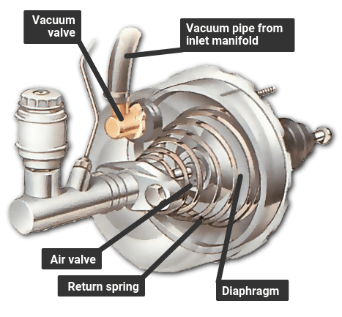](https://www.howacarworks.com/illustrations/servo-assisted-braking)

**Fig 2.3: The Brake Servo**

**A direct-acting servo is fitted between the brake pedal and the master cylinder. The pedal can work the master cylinder directly if the servo fails or if the engine is not running.**

1. **Brake Servo:** A direct-acting servo is fitted between the brake pedal and the master cylinder. The brake pedal pushes a rod that in turn pushes the master-cylinder piston.

But the brake pedal also works on a set of air valves, and there is a large rubber diaphragm connected to the master-cylinder piston.

When the brakes are off, both sides of the diaphragm are exposed to the vacuum from the manifold.

Pressing the brake pedal closes the valve linking the rear side of the diaphragm to the manifold, and opens a valve that lets in air from outside.

The higher pressure of the outside air forces the diaphragm forward to push on the master-cylinder piston, and thereby assists the braking effort.

If the pedal is then held, and pressed no further, the air valve admits no more air from outside, so the pressure on the brakes remains the same.

When the pedal is released, the space behind the diaphragm is reopened to the manifold, so the pressure drops and the diaphragm falls back.

If the vacuum fails because the [engine](https://www.howacarworks.com/basics/the-engine) stops, for example the brakes still work because there is a normal mechanical link between the pedal and the master cylinder. But much more force must be exerted on the brake pedal to apply them.

**How the brake servo works**

[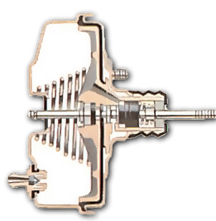](https://www.howacarworks.com/illustrations/how-the-brake-servo-works)

**Brake off - both sides of the diaphragm are under vacuum.**

[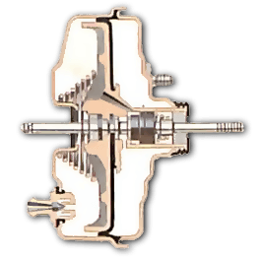](https://www.howacarworks.com/illustrations/how-the-brake-servo-works--2)

**Fig 2.4: Side View of a Brake Servo**

**Applying the brake lets air in behind the diaphragm, forcing it against the cylinder.**

Some cars have an indirect-acting servo fitted in the hydraulic lines between the master cylinder and the brakes. Such a unit can be mounted anywhere in the engine compartment instead of having to be directly in front of the pedal.

It, too, relies on manifold vacuum to provide the boost. Pressing the brake pedal causes hydraulic pressure build up from the master cylinder, a valve opens and that triggers the vacuum servo.

1. **Disc brake:** The basic type of disc brake, with a single pair of pistons. There may be more than one pair, or a single piston operating both pads, like a scissor mechanism, through different types of calipers - a swinging or a sliding caliper.

A disc brake has a disc that turns with the wheel. The disc is straddled by a caliper , in which there are small hydraulic pistons worked by pressure from the master cylinder.

The pistons press on friction pads that clamp against the disc from each side to slow or stop it. The pads are shaped to cover a broad sector of the disc.

There may be more than a single pair of pistons, especially in dual-circuit brakes.

The pistons move only a tiny distance to apply the brakes, and the pads barely clear the disc when the brakes are released. They have no return springs .

[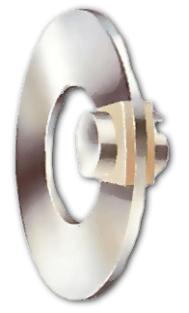](https://www.howacarworks.com/illustrations/disc-brakes--2)

**Fig 2.5: Side View of a Brake Disk**

**When the brake is applied, fluid pressure forces the pads against the disc. With the brake off, both pads barely clear the disc.**

Rubber sealing rings round the pistons are designed to let the pistons slip forward gradually as the pads wear down, so that the tiny gap remains constant and the brakes do not need adjustment.

Many later cars have wear sensors leads embedded in the pads. When the pads are nearly worn out, the leads are exposed and short-circuited by the metal disc, illuminating a warning light on the instrument panel.

[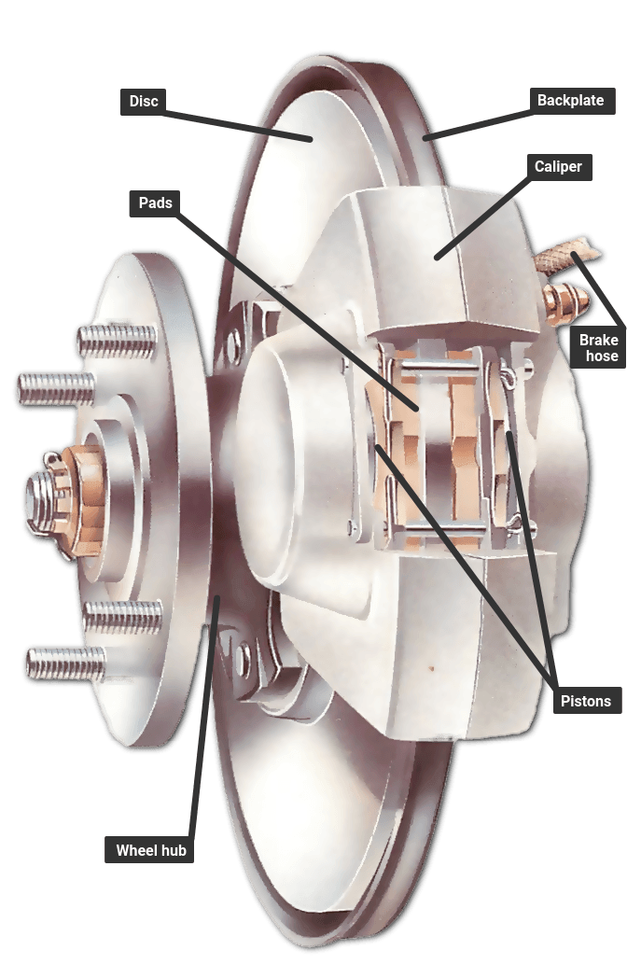](https://www.howacarworks.com/illustrations/disc-brake)

**Fig 2.6: A Comprehensive Overlay of the “Disc brake”**

**The basic type of disc brake, with a single pair of pistons. There may be more than one pair, or a single piston operating both pads, like a scissor mechanism, through different types of calipers - a swinging or a sliding caliper.**

**Drum brakes**

[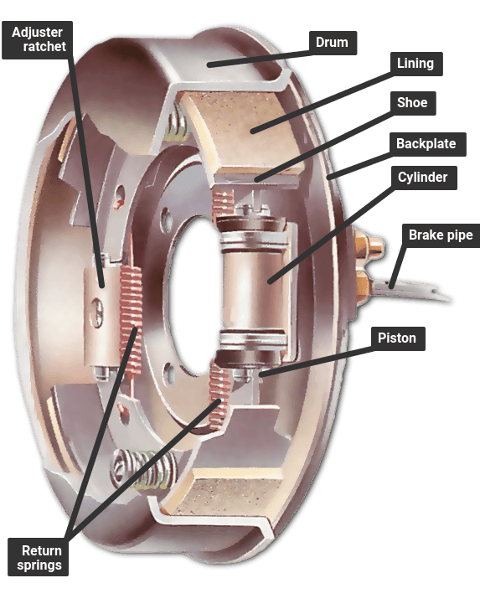](https://www.howacarworks.com/illustrations/drum-brake)

**Fig 2.7: A Comprehensive overview of the “Drum brake”**

**A drum brake with a leading and a trailing shoe, which has only one hydraulic cylinder; brakes with two leading shoes have a cylinder for each shoe and are fitted to the front wheels on an all-drum system.**

A drum brake has a hollow drum that turns with the wheel. Its open back is covered by a stationary backplate on which there are two curved shoes carrying friction linings.

The shoes are forced outwards by hydraulic pressure moving pistons in the brake's wheel cylinders, so pressing the linings against the inside of the drum to slow or stop it.

[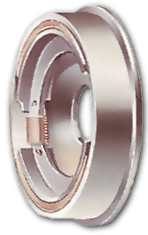](https://www.howacarworks.com/illustrations/drum-brakes)

**Fig 2.8: Brake Shoes**

**With the brakes on, the shoes are forced against the drums by their piston.**

Each brake shoe has a pivot at one end and a piston at the other. A leading shoe has the piston at the leading edge relative to the direction in which the drum turns.

The rotation of the drum tends to pull the leading shoe firmly against it when it makes contact, improving the braking effect.

Some drums have twin leading shoes, each with its own hydraulic cylinder; others have one leading and one trailing shoe - with the pivot at the front.

This design allows the two shoes to be forced apart from each other by a single cylinder with a piston in each end.

It is simpler but less powerful than the two-leading-shoe system, and is usually restricted to rear brakes.

In either type, return springs pull the shoes back a short way when the brakes are released.

Shoe travel is kept as short as possible by an adjuster. Older systems have manual adjusters that need to be turned from time to time as the friction linings wear. Later brakes have [automatic](https://www.howacarworks.com/basics/how-automatic-gearboxes-work) adjustment by means of a ratchet.

Drum brakes may fade if they are applied repeatedly within a short time - they heat up and lose their efficiency until they cool down again. Discs, with their more open construction, are much less prone to fading.

1. **The handbrake**

Apart from the hydraulic braking system, all cars have a mechanical handbrake acting on two wheels - usually the rear ones.

The handbrake gives limited braking if the hydraulic system fails completely, but its main purpose is as a parking brake.

The handbrake lever pulls a cable or pair of cables linked to the brakes by a set of smaller levers, pulleys and guides whose details vary greatly from car to car.

A ratchet on the handbrake lever keeps the brake on once it is applied. A push button disengages the ratchet and frees the lever.

On drum brakes, the handbrake system presses the brake linings against the drums.

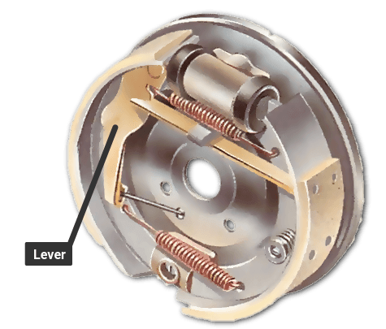

**FIG 2.9: The handbrake mechanism**

The handbrake acts on the shoes by means of a mechanical system, separate from the hydraulic cylinder, consisting of a lever and arm in the brake drum; they are operated by a cable from the handbrake lever inside the car.

**2.1.2 Common Brake System Faults and their solutions**

There are many faults which can occur in the braking system overtime. Some of these faults include;

1. **Squeaking Brake Problem:** This is a problem that occurs probably due to low quality brake pads, rotors that need to be "turned" (smoothed out by removing a small amount of their metal surface), dust and grime, etc.

**Solution:** Replacement of the brake pads and/or smoothening the rotor surface.

1. **Brake Pedal Goes to the Ground Completely When Stepped on:** The most likely cause of this brake problem is an internally leaking master cylinder. This is a common problem with brakes. What happens is the seals inside the master cylinder get old and brittle or crack so they cannot hold the pressure that is needed in your braking system. Since it leaks on the inside, there is no external leaking. **Solution:** Replacement of the Brake Servo
2. **Car Refuses to Stop When the Brakes are Applied:** This is a very common problem, which may be caused due to the malfunction of many brake components, which include;
3. **Worn out brake pads:** The vehicle will have problems stopping even when the brakes are applied, due to worn out brake pads.

**Solution:** This problem can be resolved, by replacing the brake pads.

1. **Faulty brake caliper:** When the brakes are applied to halt the motion of a car, the Caliper Pistons (Slave Pistons), clamps the brake pads, to the brake disks, thus stopping the vehicles motion. So when the caliper pistons are faulty, they will not be able to clamp the brake pads to the brake disks.

**Solution:** This problem can be solved, by servicing the brake piston cylinders (washing and scrubbing off any particle that might be causing the stiffness), and then oil the piston, before putting it back into the caliper.

1. **Leak in the braking system:** The first thing that might be happening is that there might be a leak in the caliper piston seal. If this is the case it is just a matter of replacing the brake caliper and bleeding the brake system.

Also, one of the most common cause of this problem, is a bad brake hose.

**Solution:** If this is the case, then the brake hose just needs to be replaced and bled.

**2.2.0 THE SUSPENSION SYSTEM**

The suspension system, is the system in an automobile that is responsible for linking the wheels of the vehicle, to the chassis of the vehicle. The suspension system is a very fundamental part of any automobile vehicle because without this system, there cannot be motion in the automobile. It is also endowed with the responsibility of adding comfort to the vehicle in motion, by reducing the effects of bad roads and other road bumps.

* + 1. **Components of the automobile suspension System**

1. **SHOCK ABSORBERS AND STRUT:** While springs absorb the bumps, shock absorbers (or, in cars that have them, struts, which are similar to shocks) dampen the motion of the springs after a bump, keeping the vehicle from bouncing excessively.

Shocks and struts are filled with a thick oil, and over time the oil can leak out, causing the shock or strut to fail. Impacts and accidents can also cause leakage or can damage delicate internal parts.

1. **SPRINGS:** Every car and truck today has some sort of mechanism to absorb large bumps, and this always includes some form of spring, a metal part that bends in response to force. (A few cars over the years, particular those made by Chrysler, have used torsion bars — metal rods that absorb impacts by twisting instead of bending — instead of coil or leaf springs, but these are all different forms of spring.)

Springs can sometimes break when the vehicle hits a bump very hard, and many will sag eventually (after many years), but in general these parts are much less prone to failure than most other suspension components.

1. **WHEELS AND TYRES:** Tires aren’t always considered part of the suspension, but they’re arguably the most important component of it. Tires provide traction for acceleration, braking, and cornering, and they absorb small bumps.

Tires wear over time, and are subject to cuts and punctures from hitting sharp objects, and to slow or sudden leaks from impacts. On the other hand, wheels fail (from bending or cracking) much less often, usually only in response to hard impacts from accidents or hitting potholes

1. **LINKAGES:** Every suspension includes various rods and other connecting pieces that collectively keep the wheels where they’re supposed to be relative to the rest of the vehicle. Most of these linkages are solid metal parts that rarely fail except in major accidents. However, sometimes linkages and associated bushings are sold together, and the failure of a bushing can necessitate replacing the whole assembly.
2. **HYDRAULIC POWER STEERING:** Many vehicles are equipped with power steering. Of the two types of power steering, hydraulic systems (i.e., those that use a high-pressure fluid to help the driver turn the wheels) are more failure-prone. Fluid can leak from high-pressure lines, delicate valves occasionally wear out, the belt that drives the power steering pump can loosen or break, and eventually the pump itself may fail.
3. **ELECTRIC POWER STEERING:** More and more power steering systems found in modern cars and trucks are electric, not hydraulic. Electric power steering systems include various sensors, wires, and actuators (motors), any of which can fail, but luckily such failures are less common than failures of hydraulic components.
4. **STEERING SYSTEM — ALL TYPES:** Every steering systems contains numerous linkages, some joints such as the tie rod ends mentioned above, and some sort of steering box, the mechanical device that converts rotation of the steering wheel into movement of the car’s wheels.

In general, linkages aren’t very likely to fail, while components such as tie rod ends are. Steering boxes wear out eventually, with rack-and-pinion steering systems in vehicles equipped with hydraulic power steering being the most failure prone.

1. **BUSHINGS:** Because most parts of any suspension must be movable, the various linkages are connected by flexible connections. These include bushings and bearings, which are connections that allow a small amount of twisting or sliding, often without needing lubrication, and joints, which in automotive applications often use a lubricant such as grease to allow for controlled movement.

Some suspension bushings are made of rubber, which can become brittle or break over time, leading to failure. Many joints tend to wear out, leading initially to looseness and eventually to failure. A couple of the most common culprits are tie rod ends, which are lubricated joints that connects certain steering linkage parts, ball joints, which are found in both the steering system and attached to the control arms, and the bushings that separate the control arms from the vehicle’s frame.

There are various ways of attaching the wheels of the car so that they can move up and down on their springs and dampers, and do so with as little change as possible in the distance between adjacent wheels or in the near-vertical angle of the tyres to the road.

The front wheels must be free to pivot on their steering swivels. The driven wheels, whether front or rear, must also be free to rotate with the drive shafts.

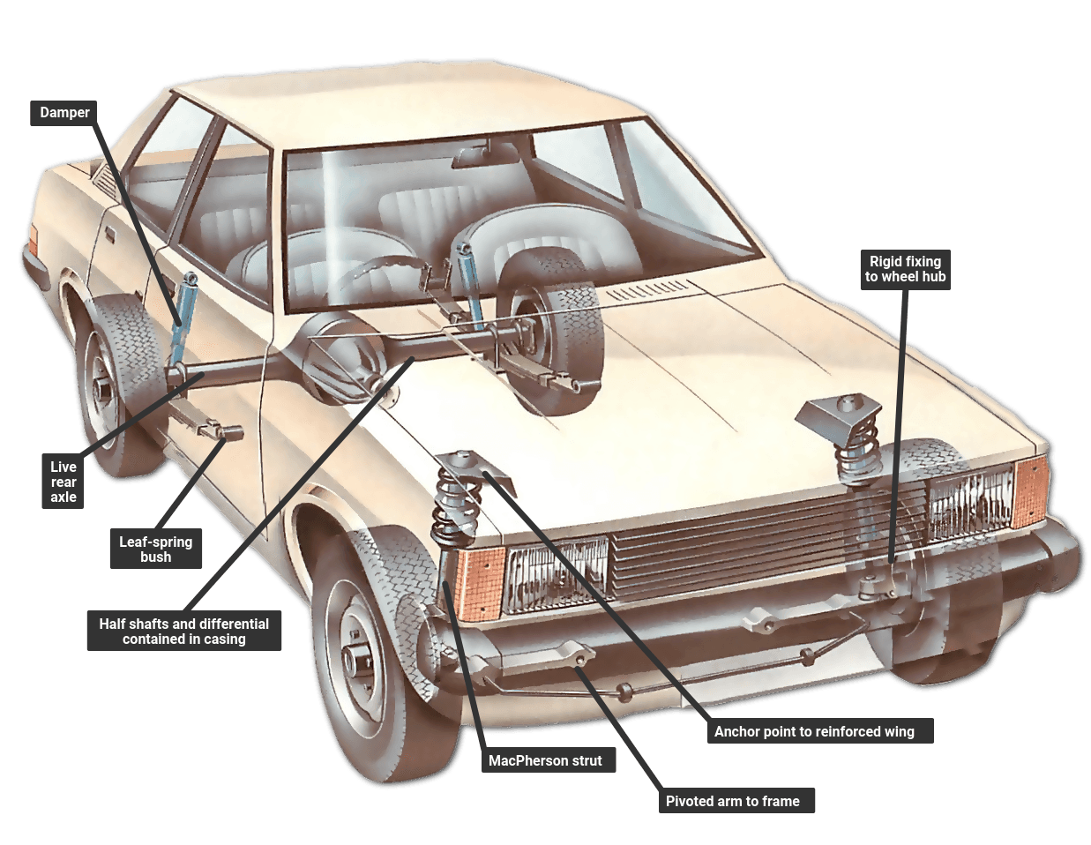

**Fig 3.0: Leaf spring and MacPherson strut**

**A typical suspension system on a rear-wheel-drive car. It has a live rear axle on leaf springs, and independent front suspension of the MacPherson-strut type with interior damper.**

**Non-independent suspension:** A rear-wheel-drive car often has a live axle, a tube containing both the drive shafts (half shafts) and the differential gears. A four-wheel-drive car may have a live front axle as well.

A dead axle - a rigid beam - is now used at the front on vans and trucks only. Some front-wheel-drive cars have a dead rear axle.

A rigid axle will have springs and links, to prevent sideways movement.

**Independent Suspension:** Instead of sharing a common axle, each wheel on a car with independent suspension is independently attached to the body or subframe. Different spring combinations may be used.

When driven wheels are independently suspended, the differential is fixed to the frame and drives the wheels by jointed drive shafts.

**2.2.2 Common Suspension system Faults and their solutions**

1. **Feeling Every Bump While Driving:** A rough ride is a clear indicator your shocks or struts could be worn and in need of replacement. When every bump on the road makes your car bounce, you’ve got suspension problems and need to get it checked out.

Try the bounce test—when your car is parked, put all of your weight on the front end, release, and observe how the vehicle responds. If it bounces back and forth 3 or more times, the shocks and/or struts are worn and need replacing.

The two main causes of this problem explained in details are;

1. **Worn out Shock Absorbers:** they are the main culprit when your car feels "bumpier" than ever. They're designed to keep your tires on the road. When they don't, the car will bounce all over the place. Shocks have fluid which dampen the bouncing. When they leak, their performance suffers and the absorbers will eventually fail.

**SOLUTION:** Replacement of the **“Shock Absorber”.**

1. **Worn out Leaf Spring:** Leaf springs may sometimes cause problems with excessive bouncing. You can double check the possibility of a busted leaf spring by checking if the car or truck seems to "lean" back in a standing position. Many trucks are designed to be "nose down" to accommodate extra weight in the rear. If your pickup truck appears to sit level, it could be extra proof of an issue with a leaf spring.

Even the slightest damage from an accident can cause shocks to leak and permanently damage them beyond repair. Get it checked out.

**SOLUTION:** Replacement of the **“Leaf Spring”.**

1. **Difficult Steering:** If you find steering is especially difficult, especially when you’re moving slowly, something might be wrong with your suspension. Sometimes the steering may feel like it’s “slipping” when you turn the wheel or hold it in a turned position. Any number of components in your power steering system could be a source of these issues, including:
2. Low power steering fluid
3. Worn or loose power steering belt
4. Faulty power steering pump
5. Leaking power steering rack
6. Worn control arm bushings

**SOLUTIONS:** Refilling the “power steering fluid”, replacing the “power steering belt”, replacing the “power steering pump”, replacing the “leaking power steering rack”, replacing the “control arm bushing”, etc.

1. **Pulling to One Side While Driving:** Pulling to the left or right is the most common sign of suspension problems. It can also be one of the hardest problems to diagnose without the help of a professional. Tires need to be aligned precisely for toe-in, caster and camber. Poor alignment means uneven tire wear, annoying pulling, a constant fight with the steering wheel, and even decreased gas mileage. Your vehicle could be pulling for any number of reasons, which may include;
2. Uneven tire pressure
3. Uneven tire wear
4. Poor alignment
5. Bad tie rods or steering rack
6. Sticking brake caliper

If you blow through a pothole or climb over a curb or two, your alignment can get out of whack. Sudden changes in alignment may occur as a result of a fault from probably a broken spring or control arm.

**SOLUTIONS:** Ensuring even tire pressure, ensuring proper tire alignment, replacement of tie rods or steering rack, proper placement of the brake caliper, etc.

**2.3 THE LUBRICATING SYSTEM**

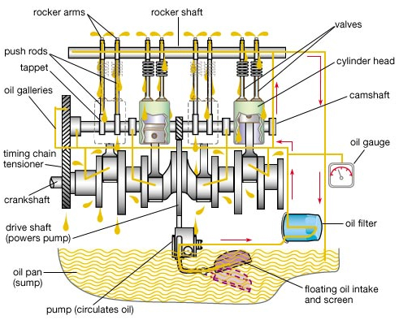

**Fig 3.1: The Lubrication System**

The engine lubrication system is to distribute oil to the moving parts to reduce friction between surfaces. Lubrication plays a key role in the life expectancy of an automotive engine. If the lubricating system fail, an engine would succumb to overheating and seizing very quickly. An oil pump is located on the bottom of the engine. The oil is pulled through a strainer, by the oil pump, removing larger contaminants from the mass of the fluid. The oil then forced through an oil filter under pressure to the main bearings and the oil pressure gauge. It is important to note that not all filters perform the same. A filter’s ability to remove particles is dependent upon many factors, including the media material (pore size, surface area and depth of filter), the differential pressure across the media, and the flow rate across the media. From the main bearings, the oil passes into drilled passages in the crankshaft and the big-end bearings of the connecting rod. The oil fling dispersed by the rotating crankshaft lubricates the cylinder walls and piston-pin bearings. The excess oil is scraped off by the scraper rings on the piston. The engine oil also lubricates camshaft bearings and the timing chain or gears on the camshaft drive. The excess oil in the system then drains back to the sump.

2.3.1 Components of the lubrication system

1. **Oil pan:** This is where Oliver hangs out when the engine isn't doing anything; the oil lounge, if you will. In most cars, this pan holds about 4 to 6 quarts of oil.
2. **Pickup tube:** When the engine is switched on, it needs oil immediately. The oil gets sucked up by the pickup tube and lined up for action.
3. **Oil pump:** The pump does the sucking so that oil can slide up that tube against gravity and then pressurizes the oil. The oil gets jammed in together even closer.
4. **Oil filter:** When the Oil is allowed to pass into the engine, the filter stops any dirt and debris the oil may have picked up on its last pass through the system.
5. **Sump:** After doing his job to keep the moving parts of the engine moving, the oil goes all the way down into the oil pan again, also known as the sump, to wait until it is sucked back up the pickup tube -- and to continue its lubricating process.

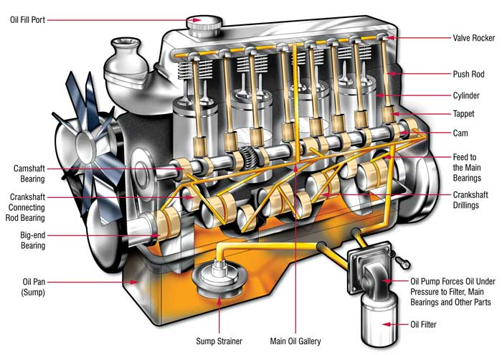

**Fig 3.2: An Engine Lubrication System**

**2.3.2 LUBRICATING SYSTEM MAINTENANCE**

There are certain lubricating system service jobs that are more or less done automatically when an engine is repaired. For example, the oil pan is removed and cleaned during such engine overhaul jobs as replacing bearing or rings. When the crankshaft is removed, it is usual procedure to clean out the oil passages in the crankshaft. Also, the oil passages in the cylinder block should be cleaned out as part of the overhaul.

Some of the Basic Lubrication System maintenance includes;

1. Oil and Filter Change: It is extremely important that the oil and filter(s) of the engine are serviced regularly. Lack of oil and filter maintenance will greatly shorten engine service life. Manufacturers give a maximum number of miles or hours a vehicle can be operated between oil changes. Newer automotive vehicles can be operated 5,000 miles between changes. Older automotive vehicles should have their oil changed about every 3,000 miles. Most construction equipment average between 200 and 250 hours of operation between oil changes. However, depending on the climate and working conditions the miles and hours between oil changes can be greatly reduced. Refer to the service manual for exact intervals.

**Changing the Engine Oil and Oil Filter of a Car**

To change the engine oil, warm the engine to full operating temperature. This will help suspend debris in the oil and make the oil drain more thoroughly. Unscrew the drain plug and allow the oil to flow into a catchment pan be careful of hot oil; it can cause painful burns.

Usually the filter elements are replaced at the same time the oil is changed. The most common filters are the spin-on filter or replaceable element type oil filter.

* **Spin-on, throwaway oil filter**: replaced as a complete unit. Unscrew the filter from the base by hand or a filter wrench and throw the filter away. When replacing, wipe the base clean with a cloth and place a small amount of oil or grease on the gasket to ensure a good seal. Screw on a new filter, tightening at least a half a turn after the gasket contacts the base. Do not use a filter wrench because the filter canister could distort and leak.
* **Replaceable element oil filter:** removed from the filter housing and replaced. Place a pan underneath the filter to catch oil from the filter. Remove the fastening bolt and lift off the cover or filter housing. Remove the gasket from the cover or housing and throw it away. Take out the old element and throw it away. Clean the inside of the filter housing and cover it. Install a new element and insert a new cover or housing gasket (ensure the gasket is completely seated in the recess). Replace the cover or housing and fasten it to the center bolt securely.

After the oil has been completely drained and the drain plug replaced, fill the crankcase to the full mark on the dipstick with the proper grade and weight of oil. Start and idle the engine. Check the oil pressure immediately. Inspect the filter or filter housing for leaks. Stop the engine and check the crankcase oil level and add to the full mark.

1. **OIL PUMP SERVICE:** Service on oil pumps is limited since they are relatively trouble-free. An oil pump will often still be operating trouble-free when the vehicle is ready for salvage.

A bad oil pump will cause low or no oil pressure and possibly severe engine damage. When inner parts wear, the pump may leak and have a reduced output. The pump shaft can also strip in the pump or distributor, preventing pump operation

To replace the oil pump, it is first necessary to determine its location. Some pumps are located inside the engine oil pan others are on the front of the engine under a front cover or on the side of the engine. Since removal procedures vary, refer to the manufacturer's service manual for instructions.

Most mechanics install a new or factory rebuilt pump when needed. It is usually too costly to completely rebuild an oil pump in the shop. Before installation, prime (fill) the pump with engine oil. This will assure proper initial operation upon engine starting.

Install the pump in reverse order of removal. Anew gasket should be used and the retaining bolts torqued as specified by the service manual.

1. **PRESSURE RELIEF VALVE SERVICE:** A faulty pressure relief valve can produce oil pressure problems. The valve may be located in the oil pump, filter housing, or engine block.

If symptoms point to the pressure relief valve, it should be disassembled and serviced. Cleaning and adjusting is all that is usually required. Remove the cup or cap, holding the pressure relief valve. Then, slide the spring and piston out of their bore.

Measure the free length of the spring (length of extended spring) and compare it to the specifications. If the spring is too short or long, install a new spring. Some manufacturers recommend checking spring tension.

Use a micrometer and a small hole gauge to check the valve and valve bore wear. Also, check the sides of the valve for scratches or scoring. Replace the parts if any problems are found.

Assemble the pressure relief valve. Make sure that the valve is facing correctly in its bore. Slide the spring into place. Install any shims and the cover plug or cap. Refer to the service manual for details.

The pressure relief valve may be adjusted in one of two ways. One way is by an adjusting screw (having a jam or locknut) which adds or relives pressure on the spring. The other way is by adjusting shims that are added or removed to adjust opening pressure of the relief valve.

**2.3.3 Common Lubrication System Faults and their Solutions**

There are many faults that can arise in the lubrication system of any automobile. Some of those common faults include;

1. **HIGH OIL CONSUMPTION:** If the operator must add oil frequently to the engine, this is a symptom of high oil consumption. External oil leakage out of the engine or internal leakage of oil into the combustion chambers causes high oil consumption. A description of each of these problems is as follows:
2. **External oil leakage:** Detected as darkened oil wet areas on or around the engine. Oil may also be found in small puddles under the vehicle. Leaking gaskets or seals are usually the source of external engine oil leakage.
3. **Internal oil leakage:** Shows up as blue smoke exiting the exhaust system of the vehicle. For example, if the engine piston rings and cylinders are badly worn, oil can enter the combustion chambers and will be burned during combustion

**SOLUTION:** It should be taken to an automobile engineering workshop, where proper checking and repair of the leakage will be done by professional automobile engineers.

**NOTE: Do not confuse black smoke (excess fuel in the cylinder) and white smoke (water leakage into the engine cylinder) with blue smoke caused by engine oil.**

1. **LOW OIL PRESSURE:** Low oil pressure is indicated when the oil indicator light glows, oil gauge reads low, or when the engine lifters or bearings, rattle. The most common causes of low oil pressure are as follows:
2. Low oil level (oil not high enough in pan to cover oil pickup)
3. Worn connecting rod or main bearings (pump cannot provide enough oil volume)
4. Thin or diluted oil (low viscosity or fuel in the oil)
5. Weak or broken pressure relief valve spring (valve opening too easily)
6. Cracked or loose pump pickup tube (air being pulled into the oil pump)
7. Worn oil pump (excess clearance between rotor or gears and housing)
8. Clogged oil pickup screen (reduce amount of oil entering pump)

**NOTE:** A low oil level is a common cause of low oil pressure. Always check the oil level first when troubleshooting a low oil pressure problem.

**SOLUTION:** It should be taken to an automobile engineering workshop, where proper checking and repair will be done by professional automobile engineers.

1. **HIGH OIL PRESSURE:** High oil pressure is seldom a problem. When it occurs, the oil pressure gauge will read high. The most frequent causes of high oil pressure are as follows:
2. Pressure relief valve struckopen (not opening at specified pressure)
3. High relief valve spring tension (strong spring or spring has been improperly shimmed)
4. High oil viscosity (excessively thick oil or use of oil additive that increases viscosity)
5. Restricted oil gallery (defective block casting or debris in oil passage)

**SOLUTION:** It should be taken to an automobile engineering workshop, where proper checking ad repair will be done by professional automobile engineers.

1. **INDICATOR OR GAUGE PROBLEMS:** A bad oil pressure indicator or gauge may scare the operator into believing there are major problems. The indicator light may stay on or flicker, pointing to a low oil pressure problem. The gauge may read low or high, also indicating a lubrication system problem.

**SOLUTIONS:**

1. Inspect the indicator or gauge circuit for problems. The wire going to the sending unit may have fallen off. The sending unit wire may also be shorted to ground (light stays on or gauge always reads high).
2. To check the action of the indicator or gauge, remove the wire from the sending unit. Touch it on a metal part of the engine. This should make the indicator light glow or the oil pressure gauge read maximum. If it does, the sending unit may be defective. If it does not, then the circuit, indicator, or gauge may be faulty.

**NOTE:** Always check the service manual before testing an indicator or gauge circuit. Some manufacturers recommend a special gauge tester. This is especially important with some computer-controlled systems.

**2.4 THE TRANSMISSION SYSTEM**

**What is a Transmission?**

This is the part of the vehicle that connects to the back of the engine offering power from the engine to the wheels. The transmission uses the power created in the engine to keep the wheels spinning and keep the engine within a certain revolutions per minute range. Each car is different in the range required, so the transmission needs to be tuned to your vehicle. The arrangement of the transmission and where it sits is dependent on whether the car is all-wheel drive, front-wheel drive, or rear-wheel drive.

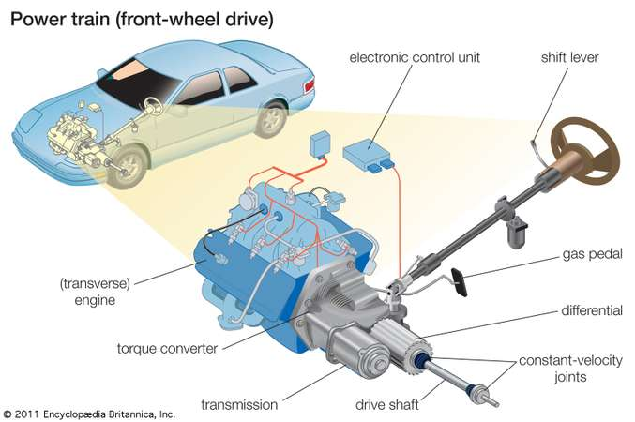

**Fig 3.3: Transmission System**

**The main elements of the power train of a front-wheel-drive automobile are the transversely mounted engine and the transmission, which transfers the torque, or turning energy, of the engine to the drive wheels through a short drive shaft.**

**Planetary Gear Set:** The planetary gear set consists of a sun gear, planet gears, and a ring gear, and is responsible for all of the gear ratios that your car uses. This is probably the most important part of your car, and everything else in the transmission depends on the planetary gear set. How it works is that the ring gear connects to the planet gears, with the sun gear in dead center. The gear ratio is determined by how the planet gears are locked or unlocked, and the planet gears revolve around the sun gear. The rotational force produced is then sent to the output shaft, which is connected to the wheels.

**2.4.1 Components of the transmission System**

1. **The Hydraulic System:** This is a system that helps control the shifting of gears, lubricates parts for optimal performance, and keeps the entire transmission system cool. The hydraulic system is used to help manipulate the fluid within the transmission to create pressure and keep the vehicle going. The hydraulic system is an integral part of the oil pump, clutches, bands, and more to keep the transmission in good repair and well-lubricated.
2. **Torque Converter:** If you’re driving an automatic transmission car, the torque converter takes the place of a clutch. This system allows the vehicle to keep running, even when you’re stopped. The torque converter mounts between the transmission itself and the engine. While it is not inside the transmission, it is an important part of your transmission system. Using a turbine, pump, and stator, the torque converter helps keep your engine speed consistent in the optimal range. These pieces work together within the converter housing to provide power and direct the flow of oil.

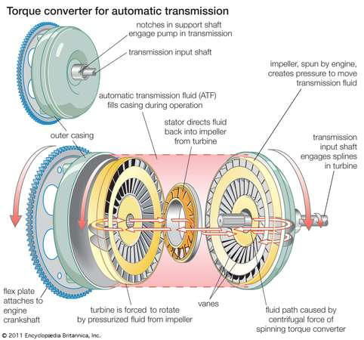

**Fig 3.4: A Torque Converter for Automatic Transmission**

1. **Sensors:** Sensors are the control units of the transmission, and calculate the speed of the engine and wheels in order to decide which gear should be used. Transmissions use both an input speed sensor as well as an output speed sensor to accomplish this, and there is also a park and neutral switch for safety.
2. **Valve Body:** The valve body is a hydraulic control center that regulates incoming transmission fluid and uses it to run a network of spring loaded valves, check balls, and servo pistons. The valves determine what gear ratio is used by sending fluid to the clutches and bands, and the pressure of the transmission fluid determines which valves are opened or closed. Fluid pressure will change depending on the engine’s speed. Nowadays, many modern automatic transmission rely on the engine control unit or the transmission control unit to regulate the valves.
3. **Automatic Transmission Fluid (ATF):** Last but not least is the automatic transmission fluid, which is CRUCIAL. Transmission fluid not only provides fluid pressure, it also has lubricating and cooling capabilities so that your transmission doesn’t overheat. ATF is made from a variety of synthetic liquids and oils with added chemical properties such as detergents, rust preventatives, and lubricants. ATF is the only part of the transmission that needs routine maintenance, as age causes it to collect contaminants as well as lose effectiveness. We recommend checking the fluid once a month and changing it every 30,000 to 60,000 miles for optimal performance.
4. **Pump:** Located between the torque converter and the planetary gear set, the pump is what draws transmission fluid in and pressurizes it for the torque converter and transmission. An automatic transmission relies heavily on fluid pressure in order for its components to function. Think of the pump as the heart of the transmission, which provides all the necessary fluid to work.

**2.4.3 Common Transmission System Faults and their Solutions**

Whether automatic or manual transmission vehicles, the transmission system remains one of the most important factors of the cars mobility. And here are a list of problems usually experienced in the transmission system of automobile vehicles.

1. When a car’s transmission goes out, you may experience a wide range of unnerving and dangerous problems. For example, a failing transmission may make it hard for the vehicle to stay in gear, which can cause the car to stall. If your transmission problems are due to low transmission fluid, you may experience a steady loss of acceleration.

**SOLUTION:** It should be taken to an automobile engineering workshop, where proper checking and repair will be done by professional automobile engineers.

1. In severe cases, when the transmission is totally out, you will not be able to power the car forward and will have to call a tow truck to pick up your vehicle.

**SOLUTION:** In these situations, the transmission usually needs to be replace. This is one of the most expensive types of car repairs.

1. Another major indicator that your car needs transmission help is when you notice issues with your gears. If you have problems shifting, accelerating, or notice slipping gearshifts then there is a serious transmission problem.

**SOLUTION:** It should be taken to an automobile engineering workshop, where proper checking and repair will be done by professional automobile engineers.

**CHAPTER THREE**

**ACTUAL WORK DONE**

**3.1 WORK DONE**

* + 1. **First Month Training**

I began my SWEP 1 internship program at Lanre Shittu Motors (LSM) Limited, and it lasted for a period of 3 months (12 weeks) that is form 10th June, 2019 to 30 August, 2019. It was a really wonderful experience, as there was a lot of skill acquired and a lot of knowledge gained during this period. I began my training, with an orientation on the do’s and don’ts which must be adhered to ensure safety of lives and properties in the workshop. Some of these workshop safety measures include;

* The general automobile workshop rules and regulations.
* Proper tool handling techniques in the automobile workshop.
* Workshop safety measures.
* Emergency management techniques in case of any automobile workshop emergency. Etc.

I moved on to vehicle maintenance. I learnt about the basic vehicle maintenance and servicing. I was also assigned duties of servicing various cars. The car servicing operations which I carried out include;

* + 1. Draining and refilling of the engine oil.
    2. Replacement of the engine oil filter.
    3. Cleaning of the *“air filter”.*
    4. Cleaning of the *"AC filter”.*
    5. Replacement of worn out front and rear brake-pads.
    6. Ensuring the brake disks are even all through, by levelling it with a sandpaper.
    7. Pumping the tire to the recommended gauge level.

I also learnt a lot of thigs on the automobile system, such as the brake system. During this period, I worked on brake system components, which include;

* Brake Servo
* Brake master
* Brake line(pipe)
* Brake disks
* Brake pads

I also learnt a lot more on the repairs and maintenance and replacement of the components of the brake system.

During the first month of my training, I gained a lot of theoretical knowledge, and I also acquired a lot of practical skill on the repairs and maintenance of automobile vehicles.

**3.1.2 Second Month Training**

In the second month of my training, I built upon the things I was taught during the first month of the training. I continued with the repairs and maintenance of automobiles, and I also had the opportunity of working much more independently, since I already had the basic knowledge required for the Job.

I also took on much more difficult tasks which include;

Replacement of leaking shock absorber.

Replacement of springs.

Replacement of the fuel pump.

Replacement of faulty water pump.

Replacement of faulty stabilizer linkage.

Servicing and replacement of spark plugs.

Replacement of plug coils.

In the second month of my training, I worked more on the suspension system of and engine components. Some of those suspension system and engine system components include;

Shock Absorbers

Springs

Stabilizer Linkage

Spark plugs

Plug coils

**3.1.3 Third Month Training**

In the third month of my training I intensified on most of the operations I had carried out earlier. The third month of the training for me was to perfect what I had learnt in the previous two months.

I worked with very little supervision, the aim was to know how well I can work alone without assistance. A lot of vehicles were assigned to me for servicing, maintenance and repairs. I also worked in teams with other of my colleagues on more tasking operations such as the repairs and maintenance of engine components, gearboxes, etc.

During this period, I was taught more about the transmission system of the automobile vehicle. I worked in groups, as I undertook more tasking operations.

Some of these operations include;

* + 1. Replacement of Engine and engine components.
    2. Replacement of Gearboxes.
    3. Replacement of the gearbox.
    4. Overhauling of the engine, etc.

During the period of these trainings, I gained a lot of theoretical knowledge, and practical skill, which would be useful for me as a mechatronics engineer.

**CHAPTER FOUR**

**EXPERIENCE GAINED AND CHALLENGE ENCOUNTERED**

**4.1 Experience gained**

There were a lot of experiences gained, during my 3 month (12 Weeks) training at Lanre Shittu Motors (LSM) Limited. Some of these experiences include;

1. Proper knowledge of the workshop rules and regulations.
2. Proper knowledge on the operation of automobile vehicles.
3. Proper automobile servicing and maintenance techniques.
4. Better exposure in terms of team work on projects.
5. Proper diagnosing procedures to identify automobile faults.
6. Better exposure working with machines like;

* Wheel Balancing Machine
* Electric cable jacks
* Pressurized air guns, etc.

**4.2 Challenges encountered**

During the course of the course of the industrial training attachment program, a few challenges were encountered and noted:

Some of these problems are general and personal. Some of which include;

1. Lack of financial incentive for internship students, to cover for some of their expenses such as feeding, transportation, etc.
2. Lack of
3. Obtaining an industrial placement is quite difficult due to congestion and bureaucracy in most organizations, and the lack of formidable existing industry partnerships between the university and key industry players.

**CHAPTER FIVE**

**CONCLUSION AND RECOMMENDATION**

**5.1 Conclusion**

In conclusion, the students work experience programme undertaken at Lanre Shittu Motors (LSM) Limited, Mabushi, Abuja, was enlightening and helpful in the development of certain skills and understanding of certain aspects related to my course of study. It provided the necessary exposure to real work situation as well as the acquisition of industrial skills that are relevant to mechatronics engineering. It also enhanced self-development by improving problem solving and creative abilities by tasking both the mental and physical faculties which provided for the acquisition of new knowledge, skills, and experience.

With respect to the above mention, I believe that I have gained experience during my period of this industrial training. During the few months period of the work experience programme, there were practical exposure to the process of automobile servicing, repairs and maintenance.

**5.2 Recommendation**.

On the basis of the complaints made in chapter four of this report, the following suggestions are made in order to curb the problem

1. The school should liaise with industries, so as to promote student incentives which would cover up for some expenses incurred during the period of this industrial training.
2. The university should establish formidable industry partnerships to foster quick absorption of students into the workforce during internships and after graduation.

REFERENCES

1. Theory of Machines Textbook by R.S Khurmi
2. <http://google.com/automobile&engineeringparts>
3. <http://howto.com/automoile/repairsandmaintainance>
4. <http://cars.com/transmissionsystemcomponents>
5. Automobile Transmission system textbook, by Jordan Smith & Michael Waters
6. <http://youtube.com/automobilesuspensionsystem>
7. <http://youtube.com/understandingthefunctionsofthelubricationsystem>